Click here
And then on this link: http://www.tvacspsangling.com/membership-form It will open a new page. If you did not have a membership, or buy online last year, then enter your email here and carry on filing the form out as it requests.
NOTE: during the form filling it will ask you for a photo to be uploaded/emailed. Please have one saved ready before you proceed. It needs to be a full face only self-portrait.
If you did buy your membership online last year then click here:
If you bought your membership online last year, then click here
Then either login using the login and password we sent you when you completed your purchase last year online or click Email Magic Link.
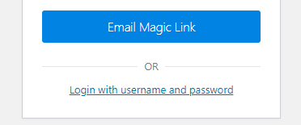
Check your email and follow the ink. Then complete the form as it requests. NOTE: during the form filling it will ask you for a photo to be uploaded/emailed. Please have one saved ready before you proceed. It needs to be a full face only self-portrait. You will need your old membership number too.

